**PROBLEM STATEMENT:**

Define a class ‘queue’ with required data members. Consider the queue as an array of elements with two pointers ‘front’ and ‘rear’ by which the elements of the queue can be accessed. Use constructors to initialize the size of the queue by default as 20, when not provided by the user. Include member functions to (i) Insert an element into the queue (ii) Delete an element from the queue (iii) Check for queue overflow and underflow. Write a menu driven program to simulate these queue operations.

**PROGRAM CODE:**

#include<iostream.h>

#include<conio.h>

class queue

{

private:

int front;

int rear;

int n;

int a[50];

public:

queue()

{ }

queue(int size)

{

front=-1;

rear=-1;

n=size;

cout<<"\nSize of queue is chosen as: "<<n<<"\n";

}

int ins(int el)

{

if(rear==n-1)

return -1;

if(rear==-1)

{

front=0;

rear=0;

a[rear]=el;

}

else

{

rear++;

a[rear]=el;

cout<<a[rear];

}

return 0;

}

int del()

{

int ret;

if(front==-1)

return -1;

else

{

ret=a[front];

if(front==rear)

{

front=-1;

rear=-1;

}

else

front++;

}

return ret;

}

void disp()

{

if(front==-1)

return;

int i;

for(i=front;i<=rear;i++)

cout<<a[i]<<"\t";

cout<<"\n";

}

};

main()

{

int ch1,ch2,elm,chk,size;

cout<<"Choose one of the following:\n1. Default size\n2. User defined size\n";

cin>>ch1;

switch(ch1)

{

case 1:

size=20;

break;

case 2:

cout<<"Enter the desired size of the queue: ";

cin>>size;

break;

}

queue q1(size);

z:

cout<<"\nChoose one of these:\n1. Insert element\n2. Delete element\n3. Exit\n";

cin>>ch2;

switch(ch2)

{

case 1:

cout<<"\nEnter the element to be inserted: ";

cin>>elm;

chk=q1.ins(elm);

if(chk==-1)

{

cout<<"\nOVERFLOW!! Delete an element before entering a new one\n";

getch();

goto z;

}

cout<<"\n\nThe queue is: ";

q1.disp();

goto z;

case 2:

chk=q1.del();

if(chk==-1)

{

cout<<"\nUNDERFLOW!! There's no element to be deleted\n";

getch();

goto z;

}

cout<<"\nThe deleted element is: "<<chk;

cout<<"\n\nThe queue is: ";

q1.disp();

goto z;

case 3:

goto y;

default:

cout<<"Enter a valid choice!";

getch();

goto z;

}

getch();

y:

return 0;

}

**OUTPUT:**

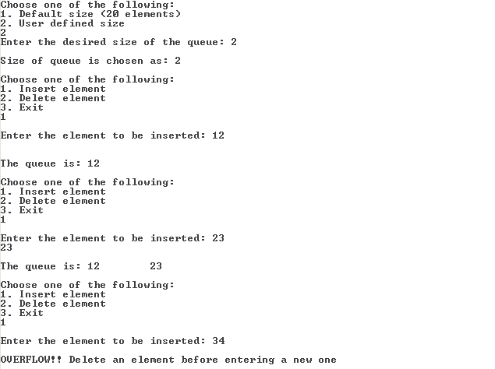

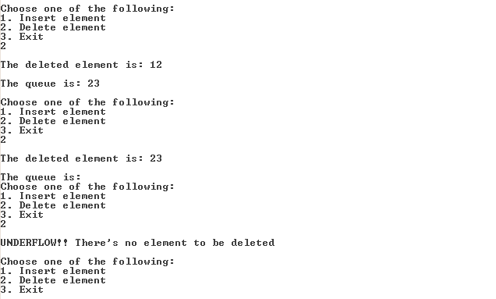

**RESULT:**

A queue is defined using a class and its size is initialized through constructors. A main program is written as well, to simulate queue operations like insertion and deletion.